Low Level Design (LLD)

Data Visualization of Bird Strikes between 2000 – 2011

ANAND NARESH RAJAK

**Contents**

1 Introduction ……………………………………………………………………………... 3

1.1 What is Low-Level design document? ............................................................... 3

1.2 Scope ……………………………………………………………………………..….. 3

2 Architecture........................................................................................................... 4

2.1 Components of Power BI ………………………………………………………...… 4

3 Architecture Description …………………………………………………………….... 6

3.1 Data Description ………………………………………………………………...….. 6

3.2 Data Transformation ……………………………………………………………...... 6

3.3 Data Insertion into Power BI ………………………………………………………. 6

3.4 Deployment ………………………………………………………………………….. 7

4 Unit Test Cases ……………………………………………………………………..… 8

**1. Introduction**

**1.1 What is Low-Level design document?**

The goal of the Low-Level Design document (LLD) is to give the internal logic design of the actual program code for the Data Visualization of Bird Strikes between 2000 – 2011. LLD describes the class diagrams with the methods and relations between classes and programs specs.

**1.2 Scope**

The Low-Level Design (LLD) is a component-level design process that follows a step-by-step refinement process. The process can be used for designing data structures, required software architecture, source code and ultimately, performance algorithms. Overall, the data organization may be defined during requirement analysis and then refined during data design work.

**2. Architecture**

Power BI architecture is a service built on top of Azure. There are multiple data sources that Power BI can connect to. Power BI Desktop allows you to create reports and data visualizations on the dataset. Power BI gateway is connected to on-premise data sources to get continuous data for reporting and analytics. Power BI services refer to the cloud services that are used to publish Power BI reports and data visualizations. Using Power BI mobile apps, you can stay connected to their data from anywhere. Power BI apps are available for Windows, iOS, and Android platforms.

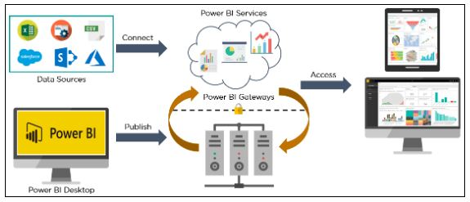

**2.1 Components of Power BI**

1. **Power Query**: Power Query is the data transformation and mash up the engine. It enables you to discover, connect, combine, and refine data sources to meet your analysis need. It can be downloaded as an add-in for Excel or can be used as part of the Power BI Desktop.

2. **Power Pivot:** Power Pivot is a data modeling technique that lets you create data models, establish relationships, and create calculations. It uses Data Analysis Expression (DAX) language to model simple and complex data.

3. **Power View:** Power View is a technology that is available in Excel, Sharepoint, SQL Server, and Power BI. It lets you create interactive charts, graphs, maps, and other visuals that bring your data to life. It can connect to data sources and filter data for each data visualization element or the entire report.

4. **Power Map:** Microsoft's Power Map for Excel and Power BI is a 3-D data visualization tool that lets you map your data and plot more than a million rows of data visually on Bing maps in 3-D format from an Excel table or Data Model in Excel. Power Map works with Bing maps to get the best visualization based on latitude, longitude, or country, state, city, and street address information.

5. **Power BI Desktop**: Power BI Desktop is a development tool for Power Query, Power Pivot, and Power View. With Power BI Desktop, you have everything under the same solution, and it is easier to develop BI and data analysis experience.

6. **Power Q&A:** The Q&A feature in Power BI lets you explore your data in your own words. It is the fastest way to get an answer from your data using natural language. An example could be what was the total sales last year? Once you've built your data model and deployed that into the Power BI website, then you can ask questions and get answers quickly.

**3. Architecture Description**

**3.1 Data Description**

1. Record ID
2. Aircraft: Type
3. Airport: Name
4. Altitude bin
5. Aircraft: Make/Model
6. Wildlife: Number struck
7. Wildlife: Number Struck Actual
8. Effect: Impact to flight
9. FlightDate
10. Effect: Indicated Damage
11. Aircraft: Number of engines?
12. Aircraft: Airline/Operator
13. Origin State
14. When: Phase of flight
15. Conditions: Precipitation
16. Remains of wildlife collected?
17. Remains of wildlife sent to Smithsonian
18. Remarks
19. Wildlife: Size
20. Conditions: Sky
21. Wildlife: Species
22. Pilot warned of birds or wildlife?
23. Cost: Total $
24. Feet above ground
25. Number of people injured
26. Is Aircraft Large?

**3.2 Data Transformation**

In the Transformation Process, we will convert our original datasets with other necessary attributes format.

**3.3 Data Insertion into Power BI**

In the Data Insertion Process, we will load our data inside Power BI Software.

**3.4 Deployment**

Once we have completed our dashboard preparation we have save the file with .pbix extension.

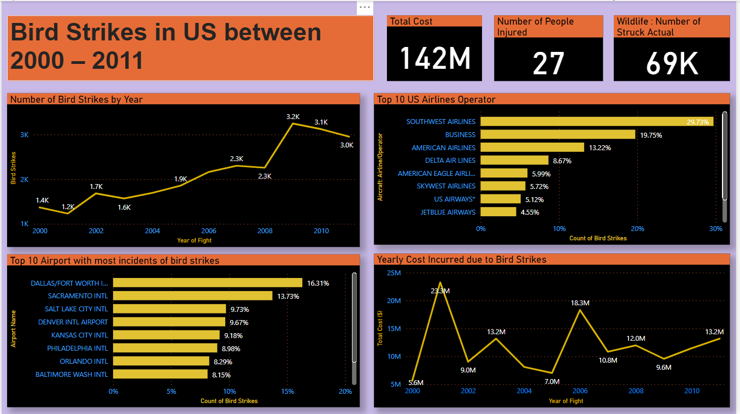

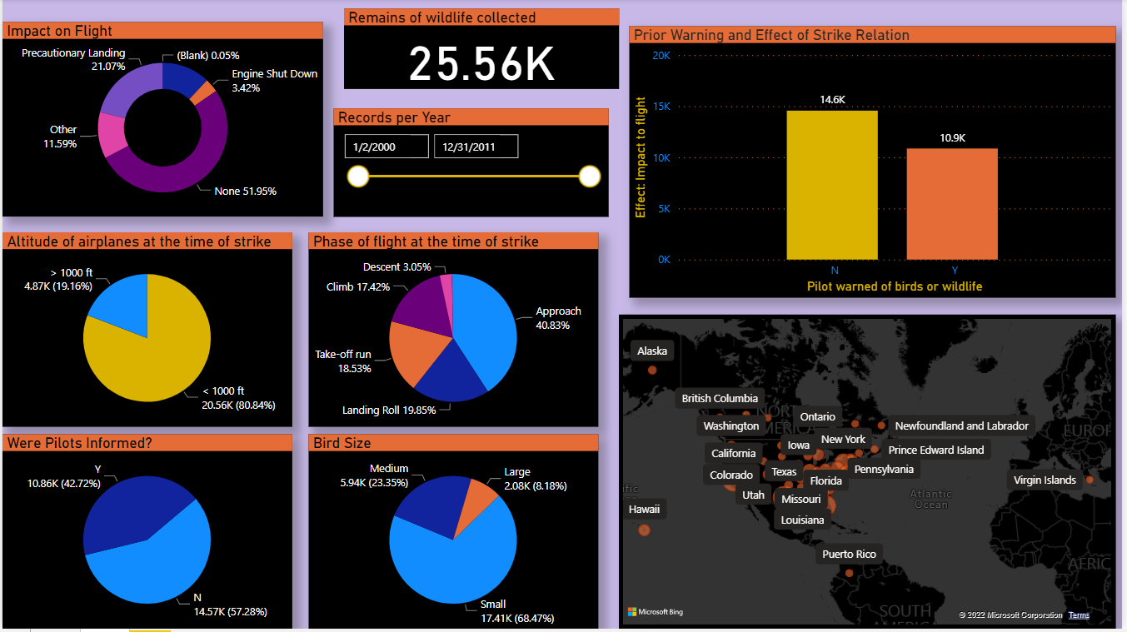

**4. Unit Test Cases**

|  |  |
| --- | --- |
| TEST CASE DESCRIPTION | EXPECTED RESULTS |
| Yearly Analysis | Year wise data shown with the help of line chart. |
| Top 10 US Airlines in terms of having encountered bird strikes | Airlines wise data shown with the help of Stacked Bar Chart. |
| Airports with most incidents of bird strikes | Airport wise data shown with the help of Stacked Bar Chart. |
| Yearly Cost Incurred due to Bird Strikes | Yearly cost incurred due to bird strikes shown with the help of line chart. |
| Altitude of airplanes at the time of strike | Altitude of airplanes at the time of strike shown with the help of pie chart |
| Phase of flight at the time of strike | Phase of flight at the time of strike shown with the help of pie chart |
| Impact on Flight | Impact on Flight shown with the help of Donut Chart |
| Were Pilots Informed? | Were Pilots Informed shown with the help of pie chart |
| Prior Warning and Effect of Strike Relation | Prior Warning and Effect of Strike Relation shown with the help of Stacked Column Chart. |